1. IDENTIFICATION OF THE PRODUCT AND THE COMPANY
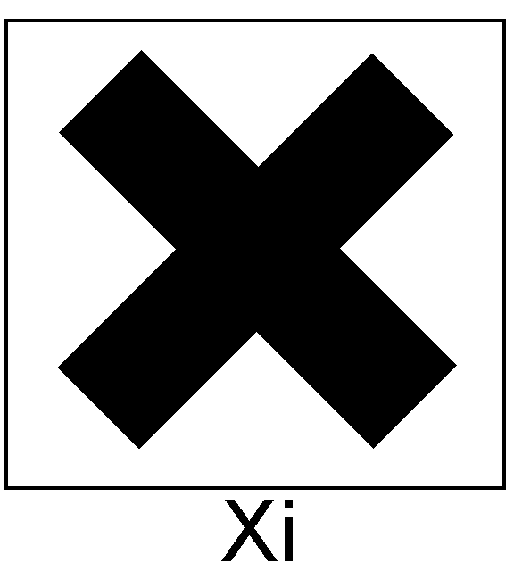
1.1 Identification of the preparation:
Trade name: INDURENT LIQUID
Trade code: C100390
1.2 Utilization of the substance or of the preparation:
Catalyst for condensation silicone
1.3 Identification of the company:
Supplier:Zhermack S.P.A. VIA BOVAZECCHINO, 100 -45021- BADIA POLESINE (RO) ITALY
Emergency telephone number of the company: TEL. 0039 0425 597611
2. COMPOSITION/INFORMATION ON INGREDIENTS
Hazardous components within the meaning of EEC directive 67/548 and corresponding classification:
Ingredient | Percentage | CAS NUMBER | Symbols | R Phrases
alkylstannosiloxane | 25% - 50% | 93925-42-9 | Xi Irritant | R36 Irritating to eyes
3. HAZARDS IDENTIFICATION
PREPARATION CLASSIFIED DANGEROUS
If brought into contact with the eyes, the product causes considerable irritation which can last for over 24 hours.
4. FIRST AID MEASURES
4.1 Contact with skin: Immediately take off all contaminated clothing. Areas of the body that have - or are only even suspected of having - come into contact with the product must be rinsed immediately with plenty of running water and possibly with soap.
4.2 Contact with eyes: Wash immediately and thoroughly with running water, keeping eyelids raised, for at least 10 minutes. Following this, protect the eyes with sterile gauze or a clean, dry, handkerchief. OBTAIN A MEDICAL EXAMINATION.
4.3 Swallowing: Induce vomiting. SEEK A MEDICAL EXAMINATION IMMEDIATELY and present the safety-data sheet. A suspension of activated charcoal in water, or liquid paraffin may be administered.
4.4 Inhalation: Ventilate the premises. The patient is to be removed immediately from the contaminated premises and made to rest in a well ventilated area. Should the patient feel unwell, OBTAIN MEDICAL ATTENTION.
5. FIRE-FIGHTING MEASURES
5.1 Recommended extinguishers: Water, CO₂, foam, chemical powders, according to the materials involved in the fire.
5.2 Extinguishers not to be used: None in particular.
5.3 Risks arising from combustion: Avoid inhaling the fumes.
5.4 Protective equipment: Use protection for the respiratory tract.
6. ACCIDENTAL RELEASE MEASURES
6.1 Measures for personal safety: Use gloves and protective clothing.
6.2 Environmental measures: Limit leakages with earth or sand. If the product has escaped into a water course, into the drainage system, or has contaminated the ground or vegetation, notify the competent authorities.
  - Cleaning methods: If the product is in a liquid form, stop it from entering the drainage system. Recover the product for re-use if possible, or for elimination. The product might, where appropriate, be absorbed by inert material. After the product has been recovered, rinse the area and materials involved with water.
7. HANDLING AND STORAGE
7.1 Handling precautions: Avoid contact and inhalation of the vapours. See, too, paragraph 8 below. Do not eat or drink while working.
7.2 Incompatible materials: None in particular. See, too, paragraph 10.
7.3 Storage conditions: Keep the closed container a temperature varying from 5°C to 27°C (41-80°F).
7.4 Instructions as regards storage premises: Adequately ventilated premises.

8. EXPOSURE CONTROLS / PERSONAL PROTECTION
8.1 Precautionary measures: Give adequate ventilation to the premises where the product is stored and/or handled.
8.2 Respiratory protection: Not needed for normal use.
8.3 Protection for hands: Use protective gloves.
8.4 Eye protection: Not needed for normal use.
8.5 Protection for skin: No special precaution must be adopted for normal use.
8.6 Exposure limit(s) (ACGIH): None.
9. PHYSICAL AND CHEMICAL PROPERTIES
9.1 Appearance and colour: colourless liquid
9.2 Odour: ethylic
9.3 Boiling point: 110°C a 1013 MBARS
9.4 Flash point: 62°C with closed pot
9.5 Vapour pressure: 20°C< 42 MBAR
9.6 Relative density: 25°C, 1.05 g/cc
9.7 Solubility in water: insoluble
10. STABILITY AND REACTIVITY
10.1 Conditions to avoid: Stable under normal conditions.
10.2 Substances to avoid: None in particular.
10.3 Hazardous decomposition products: None
11. TOXICOLOGICAL INFORMATION
We do not have tossicological data at disposal about the product. Similar products have DL50 pc (rmouse)>2000 mg/Kg. Other similar products have these tossicological data: CAS 78-10-4 LD 50 (mouse) 6270 mg/Kg: can to cause eyes, skin and mucous membranes. CAS 93925-42-9 TWA as tin 2 mg/m3 for some tin compound as CAS 1067-33 -0 (mouse) 46 mg/Kg.
12. ECOLOGICAL INFORMATION
Adopt sound working practices, so that the product is not released into the environment.
13. DISPOSAL CONSIDERATIONS
Recover if possible. Dispose of the product at disposal plants or for incineration under controlled conditions. In so doing, comply with the local and national regulations currently in force.
14. TRANSPORT INFORMATION
Not classified as dangerous in the meaning of transport regulations.
15. REGULATORY INFORMATION
Medical Device CE market according to the Directive 93/42/EEC.
Symbols: Xi Irritant
R Phrases: R36 Irritating to eyes.
S Phrases: S26 In case of contact with eyes, rinse immediately with plenty of water and seek medical advice.
16. OTHER INFORMATION
The information contained herein is based on our state of knowledge at the above-specified date. It refers solely to the product indicated and constitutes no guarantee of particular quality. It is the duty of the user to ensure that this information is appropriate and complete with respect to the specific use intended. This MSDS cancels and replaces any preceding release.

